St. Francis Catholic Elementary School
691 Lilac Street, Sudbury, ON P3E 4E2
Tel: 705-674-0701
Website: st-francis.sudburycatholicschools.ca
“Encouraging life-long learning, individuality, and respect through God’s love”

December 15, 2020

RE: GUIDELINES FOR SLIDING

Dear Parent / Guardian:

The winter season is upon us. Which means that we will begin outdoor winter activities here at school. The Ontario Physical and Health Education Association (OPHEA), has recently changed the safety regulations for many activities.

Among those changes is an important change to the guidelines for sliding. This requires parents to be informed of the importance for a child to wear a “properly fitted (as per manufacturer's guidelines) and properly worn CSA approved hockey helmet or snow sport helmet certified by a recognized safety standards association (e.g. ASTM F2040, CEN 1077, Snell RS-98, CSA Z263.1).” Wearing a helmet helps prevent many head injuries including but not limited to concussions.

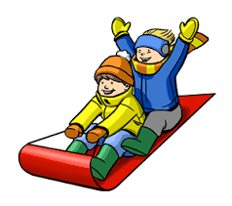
Students will be informed at least 1-2 days prior to each class sliding activity, to bring their helmets to school on the date given.

Sincerely,

Ms. Folino
Principal

Please sign and return the bottom portion to your child’s teacher.
-----------------------------------------------------------------------------------------------------------
I understand the importance for my child to wear a helmet while sliding. I have decided that for the 2020-2021 winter season:

- My child ________________________, will only go sliding when wearing the proper helmet.
- My child ____________________________, has permission to go sliding without a helmet.
________________________________________ _______________________
Parent/Guardian Signature Date

